1.prompt 2.alert 3.confirm

* alert(message): Display a popup box with the specified message with the OK button.
* confirm(message): Display a popup box with the specified message with OK and Cancel buttons.
* prompt(message, defaultValue): Display a popup box to take the user's input with the OK and Cancel buttons.

alert()

The alert() function displays a message to the user to display some information to users. This alert box will have the **OK** button to close the alert box.

confirm()

Use the confirm() function to take the user's confirmation before starting some task. For example, you want to take the user's confirmation before saving, updating or deleting data.

The confirm() function displays a popup message to the user with two buttons, OK and Cancel. The confirm() function returns true if a user has clicked on the OK button or returns false if clicked on the Cancel button. You can use the return value to process further.

prompt()

Use the prompt() function to take the user's input to do further actions.

* Syntax:

1.prompt()

<html>

    <head>

        <title>prompt</title>

    </head>

    <body>

    <button onclick="myFunction()">prompt open</button>

    <p id="demo"></p>

        <script>

            function myFunction()

            {

                let person=prompt("Enter the Name ","prashanna raj R ");

                if(person!=null)

                {

                    document.getElementById("demo").innerHTML="Hello "+person+"Most Welcome";

                }

            }

        </script>

    </body>

</html>

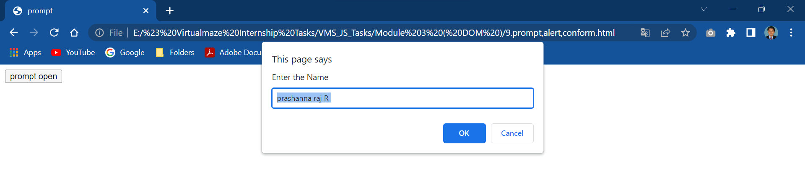

2.alert

<html>

    <head>

        <title>alert Method</title>

    </head>

    <body>

        <h1>alert() Method</h1>

        <button onclick="myFunction()">alert</button>

        <script>

            function myFunction()

            {

                alert("Hello Prashanna raj ");

            }

        </script>

    </body>

</html>

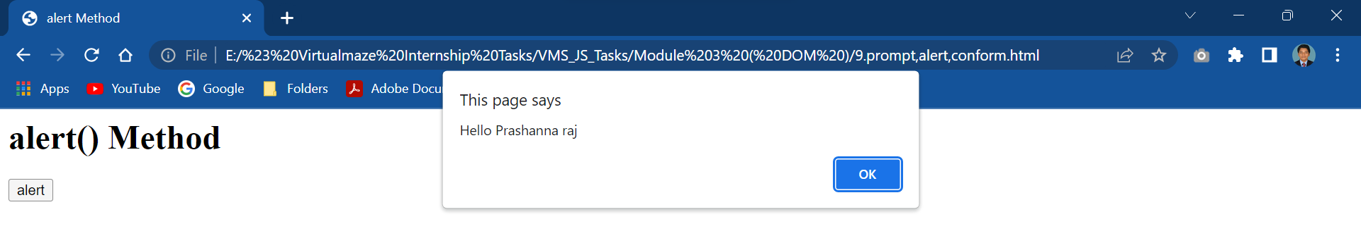

3.conform()

<html>

<body>

<h2>The conform() Method</h2>

<button onclick="myFunction()">conform</button>

<script>

function myFunction() {

  confirm("Press a button!");

}

</script>

</body>

</html>

